Q1. Draw and label the network architecture for 4G and 5G systems  
What is Homogeneous and Heterogeneous Handover

Ans.

Network Architecture for 4G

Network Architecture for 5G

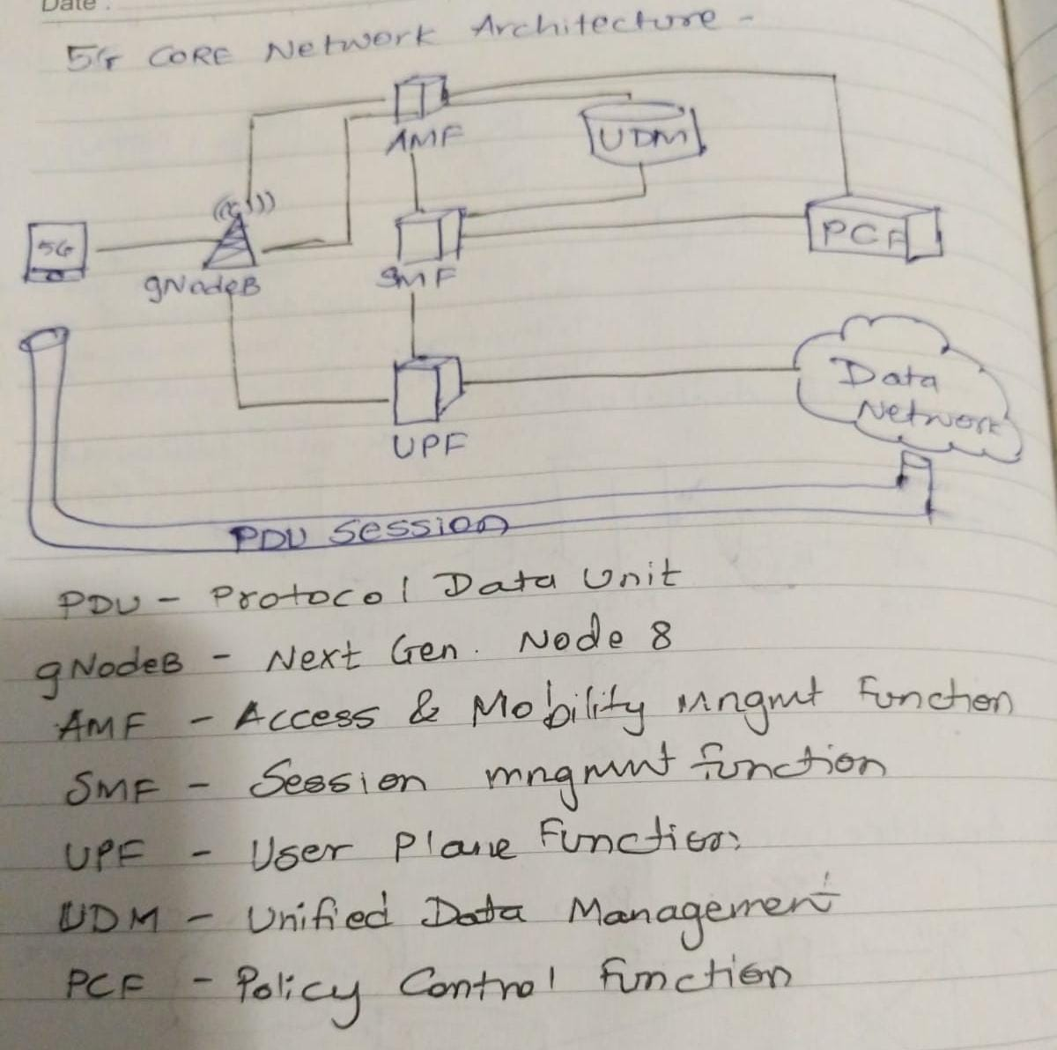

**Handover in general**

When the person moves from one cell to another within call duration and the call is transfer to the new cell’s base-station without any interruption, this process of changing the point of attachment is termed as handover or we can say that it is a process by which a Mobile Node keeps its connection active when it moves from one AP to another. There are three phases in Handoff process [4]:

1. **Handover initiation** – A mobile terminal starts searching for new links. After neighbouring networks are discovered, the mobile terminal will select the most appropriate network according to certain handover criteria and then handover negotiation will be underway [5].

2. **Handover preparation**– After a new network is selected; a new link between the mobile terminal and a base station located in the new network is setup [3].

3. **Handover execution** – After a new link is setup, all the communications associated with the old link are transferred to the new link. The control signals and data packets are allocated to the connection associated with the new base station or access point.

**Homogenous Handover –**

It is intra technology handover where the user switch between different base stations of the same access network within same network.

e.g. 2G to 3G switching in different networks

**Heterogenous Handover –**

It is Inter technology handover where user switch between base stations of different access network within different network models

e.g Mobile device/ user end device changing Network from Wifi broadband to LTE / Mobile 3G/4G network.

Q2. What are the Service Requirements of 5G?

Service Requirements of 5G –

1. Create a Common Composable Core
2. “Slice” the network to Support Different Services
3. Optimize for the Internet of Things – better communication within the vehicles, tech savvy products supporting IOT
4. Support Creation of New Mobile Services – high speed Data rates, Hold large capacity of users, provide higher frequency spectrum flexibility
5. Simplify Network Operations and Management – have major coverage of network provide secured and reliable network service, Increased capacity of the carrier.
6. Hand offs- heterogenous and homogenous also known as vertical and horizontal respectively, they are more kind if handover within single network when user switches between base stations of different access network or within same access network

Q3. What are 6 brand new technologies emerging as the foundation of 5G?

Due to faster 5G transfer rate and optimised functionality handle thousand times of more traffic and 10 times faster than 4G LTE, 5G virtual reality, IOT, autonomous driving.

Following are 6 new technologes coming up in 5G-

1. Millimetre waves
   1. House application under 6GHz
   2. Bits of data
   3. Researcher experimenting within 3kHz to 300 GHz waves which were never used before
   4. Which will provide more bandwidth by everyone
2. Small cells
   1. Broadcast signals through long distances
   2. High powered cell towers
   3. Harder time travelling through obstacles
   4. Base stations will be closely placed and relay network for mobile devices for better range of device and not to lose connection
3. Massive MIMO BS
   1. Support 100 port , increase capacity of network by 22% r more
4. Beamforming
   1. Traffic signalling for cellular signals
   2. Focus stream to a data user
   3. Station could more handling
   4. Use Signal processing algorithm to triangulate and keep signals interfering with each other
   5. Bounce individual data in each direction
   6. Coherent data streams
5. Full duplex
   1. Base stations can do one job at a time due to less atrocity
   2. Wave like a train loaded with data
   3. Opposite train will share interference
   4. Signalling system which will reroute for each data transferred on same channel
6. Network Virtualization
   1. Replacing hardware based network functions with software’s and optimize the network performance improve efficiency flexibility and capacity